# Sprint Integration Test of ISO Data Type Support within the SDK UI, RESTful API’s and Query Engine Components

## List of ISO Data Types Supported

Support for the following ISO data types have been added to SDK 4.4 at the UI and query engine levels:

* AD
* BL
* BLNONNULL
* CD
* DSET<AD>
* DSET<CD>
* DSET<II>
* DSET<TEL>
* ED
* EDTEXT
* EN
* ENON
* ENPN
* II
* INT
* IVL<INT>
* IVL<PQ>
* IVL<REAL>
* IVL<TS>
* PQ
* REAL
* SC
* ST
* STNT
* TEL
* TELEMAIL
* TELPERSON
* TELPHONE
* TELURL
* TS

## UI Unit Tests and Results

* For any given ISO data type attribute, validate that generated UI screen reflects hibernate metadata
* For any given ISO data type attribute, validate that Request Post parameters are properly submitted and received at the server
* For any given ISO data type attribute, validate that the Request Post parameters are correctly translated into a corresponding GetHTML RESTful API query
* For any given ISO data type attribute, validate that the GetHTML RESTful API query gets properly translated into a corresponding hibernate HQL query
* For any given ISO data type attribute, validate that the expected HTML results from the HQL query are returned and properly displayed in a new Window.

## RESTful API Unit Test Results

Pending: to be completed.

## A Sample of Simple ISO Data Type BL UI Search Criteria Input Screen:

The following diagram illustrates a portion of the generated Search Criteria UI screen for a simple ISO Data Type, BL (Boolean):

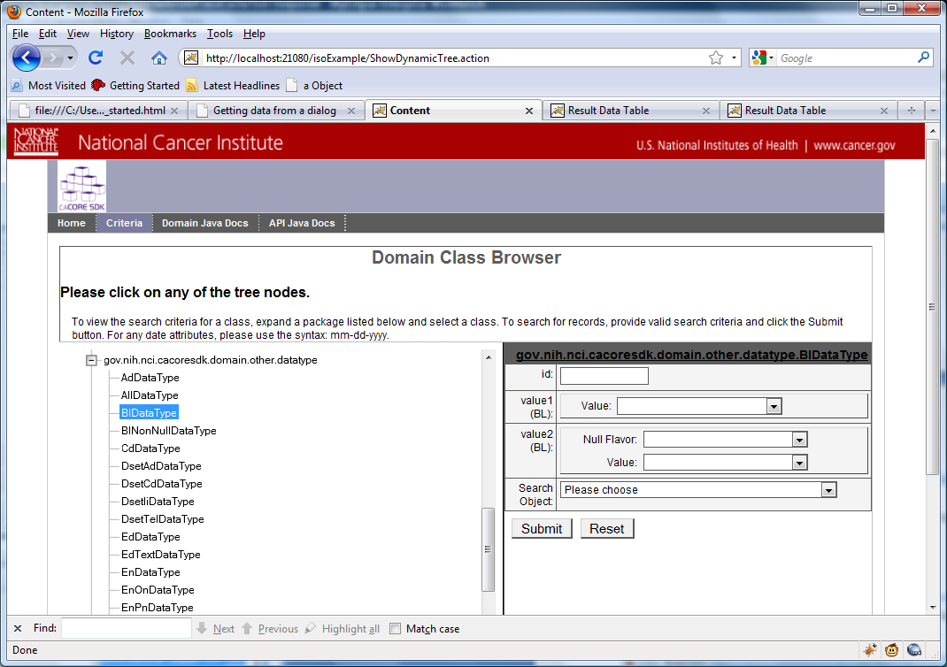

As shown, attribute ‘value1’ has a single field, ‘value’. Attribute ‘value2’ has two fields, ‘nullFlavor’ and ‘value’. This illustrates the use of the metadata to only show fields that are mapped to the database.

The corresponding Hibernate metadata used to dynamically generate this UI is shown below:

Class Name gov.nih.nci.cacoresdk.domain.other.datatype.BlDataType

Attribute Name >> value1

Fields >>>> value

Attribute Name >> value2

Fields >>>> nullFlavor , value

Attribute Name >> id

Fields >>>> id

## A Portion of Complex DSET AD UI Search Criteria Input Screen:

The following diagram illustrates a portion of the generated Search Criteria UI screen for complex ISO Data type DSET<AD>, which is basically a collection of AD (Address) parts (ADXP):

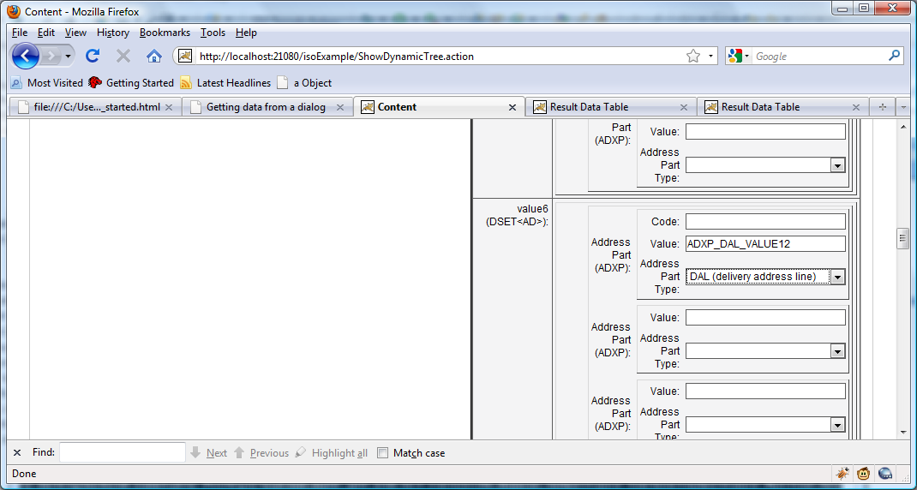

As shown, Address Part one has three fields for the ADXP part, Code, Value, and Address Part Type. Address Part Two only has two fields, Value and Address Part Type. This illustrates the use of the metadata to only show fields that are mapped to the database.

The corresponding Hibernate metadata used to dynamically generate the UI is shown below. The metadata for attribute ‘value6’ of sample Class DsetAdDatatype is highlighted:

Class Name gov.nih.nci.cacoresdk.domain.other.datatype.DsetAdDataType

Attribute Name >> value1

Fields >>>> {item<gov.nih.nci.iso21090.Ad>=[{part_0=[value]}]} ,

Attribute Name >> value4

Fields >>>> {item<gov.nih.nci.iso21090.Ad>=[{part_0=[value, code, codeSystem]}, {part_1=[value, code, codeSystem]}]} ,

Attribute Name >> value7

Fields >>>> {} ,

Attribute Name >> value2

Fields >>>> {item<gov.nih.nci.iso21090.Ad>=[{part_0=[value, code]}]} ,

Attribute Name >> value8

Fields >>>> {} ,

Attribute Name >> value5

Fields >>>> {item<gov.nih.nci.iso21090.Ad>=[{part_0=[value, code, codeSystem]}, {part_1=[code, codeSystem, value]}, {part_2=[value, code, codeSystem]}]} ,

Attribute Name >> value6

Fields >>>> {item<gov.nih.nci.iso21090.Ad>=[{part_0=[value, code]}, {part_1=[value]}, {part_2=[value]}, {part_3=[value]}, {part_4=[value, code, codeSystem]}, {part_5=[value]}, {part_6=[value]}, {part_7=[value]}, {part_8=[value]}, {part_9=[value]}, {part_10=[value, code, codeSystem]}, {part_11=[value]}, {part_12=[value]}, {part_13=[value]}, {part_14=[value]}, {part_15=[value]}, {part_16=[value]}, {part_18=[value]}, {part_19=[value]}, {part_20=[value]}, {part_21=[value]}, {part_22=[value, code, codeSystem]}, {part_23=[value]}, {part_24=[value]}, {part_25=[value]}, {part_26=[value]}, {part_27=[value, codeSystem, code]}]} ,

Attribute Name >> id

Fields >>>> id ,

Attribute Name >> value3

Fields >>>> {item<gov.nih.nci.iso21090.Ad>=[{part_0=[value, code, codeSystem]}]} ,

## Debug Output showing progression of submitted query from request parameters to RESTful GetHTML Query, to Ultimately HQL Query:

Note: The debug output listed below is shown on the Tomcat / JBoss app server console.

Request Parameters received at Server:

parameterValue: ADXP_DAL_VALUE12

isoParamPrefix: value6.item.part10

isoParamKey: value

parameterValue: ADXP_DAL_VALUE12

parameterValue: DAL

isoParamPrefix: value6.item.part10

isoParamKey: type

parameterValue: DAL

key: item

key: part10

key: value

key: type

Translated RESTful GetHTML Query Sent as a Redirect to Server:

GetHTML?query=gov.nih.nci.cacoresdk.domain.other.datatype.DsetAdDataType&gov.nih.nci.cacoresdk.domain.other.datatype.DsetAdDataType[@value6=[@item=[@part=[@value=ADXP_DAL_VALUE12][@type=DAL]]]]

### Translated HQL Query

11:00:29,942 INFO [NestedCriteria2HQL] HQL query: select dsetAdDataType_1 from gov.nih.nci.cacoresdk.domain.other.datatype.DsetAdDataType dsetAdDataType_1 inner join dsetAdDataType_1.value6.item as ad_0 where ad_0.part_10.value=? ))

HQL query: select dsetAdDataType_1 from gov.nih.nci.cacoresdk.domain.other.datatype.DsetAdDataType dsetAdDataType_1 inner join dsetAdDataType_1.value6.item as ad_0 where ad_0.part_10.value=? ))

11:00:29,949 INFO [DAO] HQL Query :select dsetAdDataType_1 from gov.nih.nci.cacoresdk.domain.other.datatype.DsetAdDataType as dsetAdDataType_1 where dsetAdDataType_1.id in (select dsetAdDataType_1.id from gov.nih.nci.cacoresdk.domain.other.datatype.DsetAdDataType dsetAdDataType_1 inner join dsetAdDataType_1.value6.item as ad_0 where ad_0.part_10.value=? )))

## Resulting HTML from Query:

Note the use of nested tables to depict ISO data type results for a particular attribute:

